**3. ReactJS- HOL**

* **Explain React components**

React components are independent, reusable pieces of UI built using JSX.  
They encapsulate logic and structure, making applications modular and maintainable.

* **Identify the differences between components and JavaScript functions**

Components return JSX and manage state or lifecycle in React apps.  
JavaScript functions are general-purpose and don’t inherently handle UI or React-specific behavior

* **Identify the types of components**

React has two main types:

class components and function components.  
Class components use ES6 classes; function components use plain functions and hooks.

* **Explain class component**

A class component is created by extending React.Component and includes lifecycle methods.  
It uses a render() method to return JSX and can manage internal state.

* **Explain function component**

A function component is a JavaScript function that returns JSX directly.  
It can use React hooks like useState and useEffect for state and side effects.

* **Define component constructor**

The constructor is a special method in class components used to initialize state.  
It also binds event handlers and receives props as its argument.

* **Define render() function**

The render() function is required in class components to return JSX.  
It defines what the UI should look like based on current props and state.

Project Structure:

**CalculateScore.js**

import '../Stylesheets/mystyle.css'

const percentToDecimal = (decimal) => {

    return (decimal.toFixed(2) + '%')

}

const calcScore = (total,goal) => {

    return percentToDecimal(total/goal)

}

export const CalculateScore = ({ Name, School, total, goal }) => (

  <div className="formatstyle">

    <h1><font color="Brown">Student Details:</font></h1>

    <div className="Name">

      <b> <span> Name: </span> </b>

      <span>{Name}</span>

    </div>

    <div className="School">

      <b> <span> School: </span> </b>

      <span>{School}</span>

    </div>

    <div className="Total">

      <b><span>Total:</span> </b>

      <span>{total}</span>

      <span>Marks</span>

    </div>

    <div className="Score">

      <b>Score:</b>

      <span>

        {calcScore(

          total,

          goal

        )}

      </span>

    </div>

  </div>

);

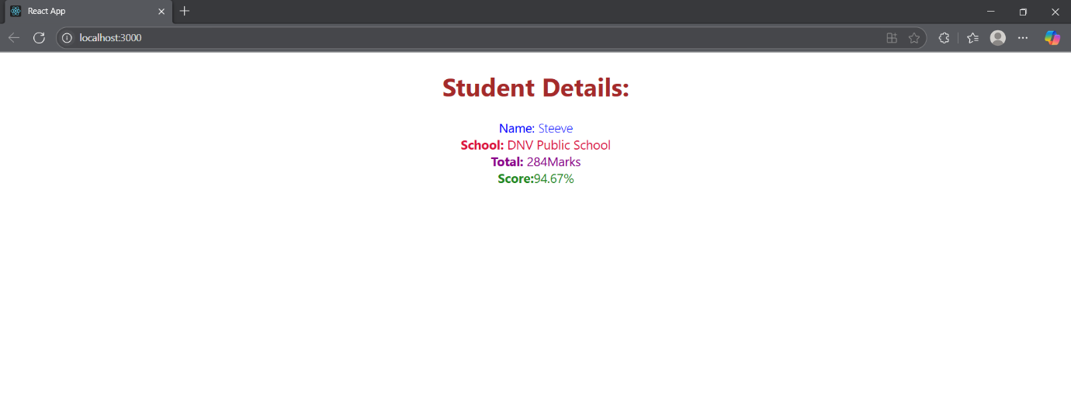Browser Output: